18. Implementing data mining techniques to discover patterns and trends in large reporting.

create database sales;
use sales;

create table sales(
sale_id int auto_increment primary key,
product varchar(100),
category varchar(50),
sale_date DATE,
quantity int,
price decimal(10,2)
);

insert into sales(product,category,sale_date,quantity,price)values
('laptop','electronics','2023-01-05',10,800.00),
('laptop','electronics','2023-02-10',5,820.00),
('headphones','electronics','2023-01-15',20,50.00),
('chair','furniture','2023-03-01',15,120.00),
('desk','furniture','2023-02-20',7,300.00),
('laptop','electronics','2023-05-05',3,810.00),
('chair','furniture','2023-01-25',10,115.00);
select category,sum(quantity)as total_quantity,sum(quantity*price)as total_revenue from sales
group by category
order by total_revenue desc;
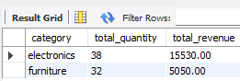

select date_format(sale_date,'%y-%m')as month,sum(quantity)as total_quantity,
sum(quantity*price)as revenue
from sales
where category='electronics'
group by month
order by month;

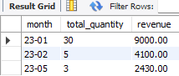

select product,sum(quantity)as total_quantity,sum(quantity*price)as total_revenue
from sales
group by product
order by total_revenue desc
limit 3;

